**SELECT**

1. Nama user gender laki-laki

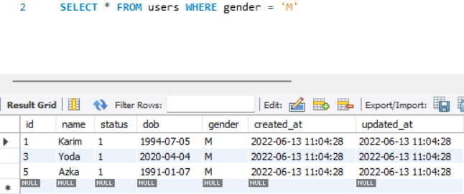

1. Tampilkan product id = 3

1. Tampilkan data pelanggan create_at 7 hari ke belakang dan nama mengandung “a”

1. Hitung jumlah users dengan jenis kelamin perempuan

1. Tampilkan data pelanggan sesuai urutan abjad

1. Tampilkan 5 data product

